Gardeners’ Circle WA Inc.

Half-Day Workshop
‘Selecting and Growing Camellias’
With John Cole

DATE and TIME: Tuesday 25 August 2015, at 9.30am
LOCATION: John Cole’s Nursery, 348 Beenyup Road, cnr Gaebler Rd, Banjup 6164 (UBD 389 C12)
Whether you’re already a camellia aficionado or, for example, simply hesitant about trying them, this presentation by John Cole himself is an opportunity to learn more in practical terms about these enduring favourites. With plants on hand to illustrate his comments he will cover topics such as:
- Species and varieties available
- Positioning
- Soil requirements
- Growing in pots
- Grafted plants

Other attractions at the nursery are:
- an extensive range of sasanqua, japonica and reticulata camellias, and of azaleas
- arguably one of the largest ranges of pots and containers in Perth
- new season’s stocks of quality deciduous trees and shrubs
- and a variety of general nursery stock, including some recent releases at very competitive prices.

$15.00 per person (non-refundable), including a light morning tea
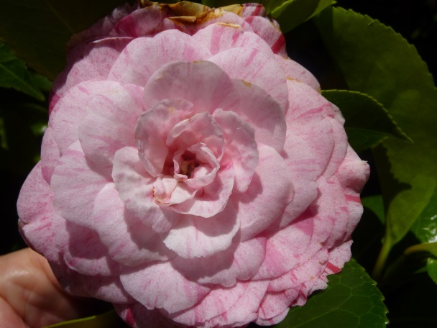
See Frances or Michael at the July or August meetings to enrol, or call or email if you can’t attend either meeting:

Michael: 9293 1950
Frances: docherty@iinet.net.au

Do you need help with car-pooling?

